Final Project Report — Programming Fundamentals
University Name: FAST NUCES Karachi
Department: Department of Computer Science
Course: Programming Fundamentals
Project Title: Library Management System
Submitted By: Muhammad Usaim Khan (25K-****)
Submitted To: Sir Sheeraz Iqbal
Semester: Fall 2025
Date: 21-Nov-2025

Abstract
The Library Management System(LMS) is a console-based program developed in C to manage essential library operations such as user authentication, automatic book inventory handling, borrowing and returning books, and fine calculation. The system follows structured and modular design along with permanent storage through text files. It demonstrates the key programming concepts such as loops, decision structures, arrays, functions, pointers and file handling. The project also incorporates tier-based membership which makes it unique from other existing LMSs. This report provides a complete overview of system’s design, features, implementations, test results, limitations and potential improvements

1.Introduction
Library management is a common real world problem where books, users and loan records must be tracked efficiently. Manual Systems often lead to errors, data loss and lack of accessibility. The goal of this project is to simulate the essential operations of a small-scale library using fundamental programming techniques.

2.Objectives
The primary goals of this LMS are:
- To design a functional console-based application using C
- To implement user authentication through sign up and login
- To maintain permanent storage of records
- To allow users to borrow books with due dates and automatic quantity adjustments
- To calculate and update fines based on user’s membership tier
- To support different tiers of membership (Silver, Gold, Platinum)
- To provide admin-specific functionalities such as adding books, removing users and check which books are borrowed
- To show clean coding practices through structured programming and modular design

3.System Design

3.1 Program Flow:
- Start Display title and login menu and load Indices for the text files
- User Chooses sign up or login or exit
- After logging in, user enters main menu
- More options are showed to admin
- User chooses different options (borrowing and returning books, paying fines and etc.) and updating files accordingly until it chooses exit or logs out to start the flow from beginning
3.2 Data Storage:
1. Users.txt stores user data in following csv format:
UserId,Email,Password,Name,Contact,fine,currently_borrowed,Tier

2. Books.txt stores user data in following csv format:
BookId,BookName,Author,Quantity

3. Borrows.txt stores user data in following csv format:
BorrowId,UserID,BookID,BorrowDate,ReturnDate,DueDate

4. Meta.txt stores 3 integers, separated by spaces , corresponding to the records in Users.txt, Books.txt and Borrows.txt

In Users.txt, Books.txt and Borrows.txt each record is stored in a line
And during the program the data of logged in user is stored in a global struct, and a flag variable to check if user is logged in or not, making it easily available to all parts of the code

3.3 Features and their Algorithms:
-Sign Up: take credentials as input and write a record to Users.txt after checking the provided email is not already in use by another account. If Sign up is successful, store user’s data in global struct
-Login: Inputs email and password to find a matching records. If login is successful, store user’s data is global struct
-Borrow Book: Check availability of book(quantity>0), then add a borrow record to Borrows.txt and decrease book count
-Return Book: Display the books borrowed by the logged in user (in the borrow record UserID == UserID of Logged in User), then asks the user which book he wants to return. Finally update the borrow record, increment book quantity and calculate fine if any
3.4 Admin-Specific Features and their Algorithms:
-Add Book: Input Book details and write a record to Books.txt
-Remove User: Input UserID and remove that user record from Users.txt
-Remove Book: Input BookID and remove that book record from Books.txt
-View Borrowed Books: Go Through Borrows.txt and fetch records where there is no return date, map that record’s userid and bookid to user name and book name respectively. Finally display UserName, BookName, Borrow Date and Due Date from each record
Deleting and Updating of records are done through temp-file approach as we can’t edit/update text files directly
3.5 Input and Output:
Input: Input user details and login/signup user
Input: Input user’s choice
Output: Perform that task and show success message. Also update file accordingly if required

4.Implementation
The Project is implemented using modular approach in C and by creating reusable functions. Some of them are:
- AppendToFile(FileName, Line): Takes filename and a line. Adds the line at the end of the file
Usage: SignUp(), AddBook() and BorrowBook()
- GetCurrentDate(*day, *month, *year): stores current date in the paramters passed through reference
Usage: ReturnBook() and BorrowBook()
- TrimNewLine(line): Removes \n from end of the string
Usage: In many functions include SignUp(), Login(), BorrowBook(), ReturnBook() and etc.
Key Features:
-Personal Accounts
-Different tiers with different privileges
-Borrow and Return Books
-Pay fine
-Check Books in Library
Admin can:
- Add books in library
-Remove users
-Remove books
-See Borrowed Books
-Smooth program flow which allows user to use it without logging in again and again
-Permanent Storage in text file in csv format
-ASCII art and colored text on console to improve user experience (using windows.h)

Membership Tiers:
Silver: 3 books can be borrowed at a time and fine of Rs100/day
Gold: 5 books can be borrowed at a time and fine of Rs75/day
Platinum: 7 books can be borrowed at a time and fine of Rs50/day

5.User guide with example
User first need to create an account and then use the functionalities provided. User needs to log in again each time it opens the project using email and password. If User tries to access any of the admin-specific functionalities, they are stopped with an error message showing this feature is for admin only
Code Snippet For Sign Up:
int SignUp(){
char email[50], password[30], name[30], contact[15];
int tier;

while (1){
printf("Enter Email: ");
fgets(email, sizeof(email), stdin);
trimNewline(email);

if (EmailExists(email)){
redPrint("This email already exists in system. Use another email\n");
continue;
}
break;
}

printf("Enter Password: ");
fgets(password, sizeof(password), stdin);
printf("Enter Name: ");
fgets(name, sizeof(name), stdin);
printf("Enter Contact Num: ");
fgets(contact, sizeof(contact), stdin);
printf("TIERS\n");
brightwhitePrint("1 - Silver: 3 Borrows at a time and fine of Rs100 per day if nook not returned\n");
yellowPrint("2 - Gold: 5 Borrows at a time and fine of Rs75 per day if nook not returned\n");
purplePrint("3 - Platinium: 7 Borrows at a time and fine of Rs50 per day if nook not returned\n");

printf("Enter Tier: ");
scanf("%d", &tier);
getchar();

// Function to write data to file in csv format
// id,Email,Password,Name,Contact,fine,currently_borrowed,Tier (if error in this, return 0)
char line[200];
int x = CreateUserLine(UCount,email,password,name,contact,0.0,0,tier,line);
if (x){
x = AppendToFile("Users.txt", line);
if (!x){
redPrint("Error in writing to file\n");
return 0;
}
} else{
redPrint("An Error Occured while creating string in csv form\n");
return 0;
}

// when user signs in, put its data in global struct
strcpy(user.email, email);
strcpy(user.name, name);
strcpy(user.contact, contact);
user.id = UCount;
user.fine = 0.0;
user.curr_borrowed=0;
user.tier = tier;
UCount++;
saveCounts();
isLoggedIn = 1;
TierSpecifics(tier);
greenPrint("Sign Up Successful!\n");
//---------------------------

return 1;
}
Example Output:
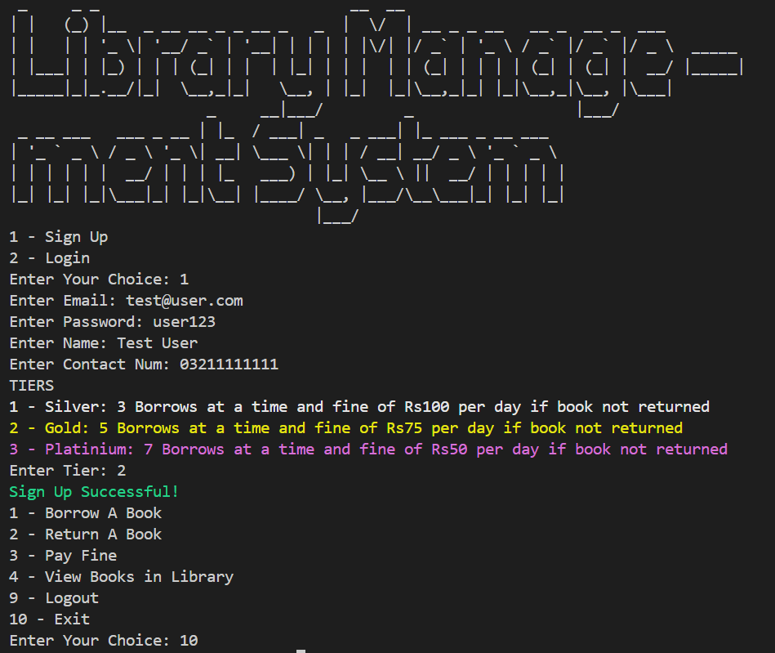

6.Testing and Results
Logging in with correct credentials | 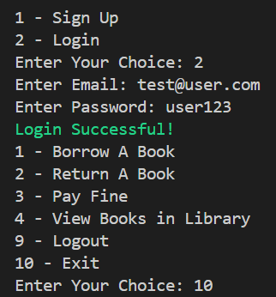 | Test passed
Logging in with wrong credentials | 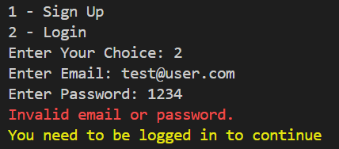 | Test passed
Extended menu for admin | 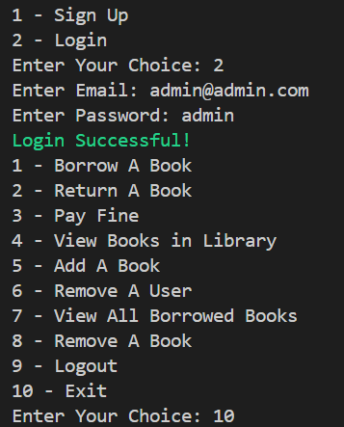 | Test passed
Normal Menu for non admin users | 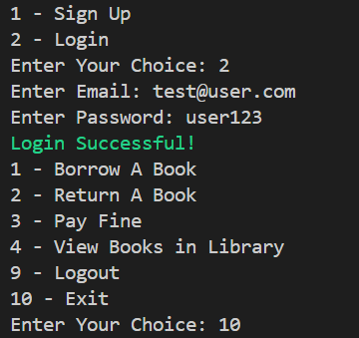 | Test passed
Borrowing a book | 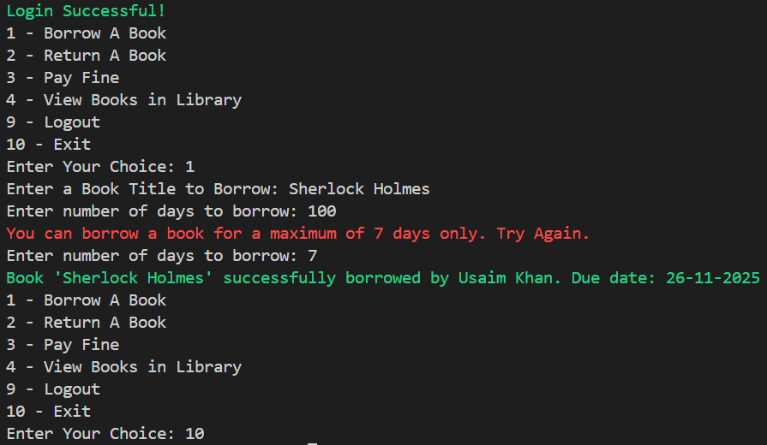 | Test  passed

7.Conclusion
The Library Management System (LMS) successfully demonstrates of the application of the basic programming principles. It automates borrowing and returning of books along with fine calculation based on user tiers with permanent storage meeting the intended objectives and provides a strong foundation for building more advance LMS. With enhancements, the project can evolve into a fully featured digital library solution.
Limitations
- Passwords are stored as plain texts
- No graphical interface
- Limited to windows OS due to color printing functions (use of windows.h)
- No use of database which is more efficient in the kind of data in project handles
Future Enhancement
- Use hashing to store password (SHA-256 or bcrypt)
- Create GUI
- Make the project cross-platform
- Integrate Sqlite database to store data instead of text files

